URL: https://adityabirlahospital.com/specialties/plastic-&-reconstructive-surgery

Meta Title: Best Plastic Surgery Hospital in Pimpri, Pune | Aditya Birla Memorial Hospital

Meta Desc: Aditya Birla Memorial Hospital is the best plastic surgery hospital in Pimpri, Pune, offering advanced cosmetic and reconstructive surgery with expert care.

Overview: Plastic and Reconstructive Surgery Centre in Pimpri, Pune

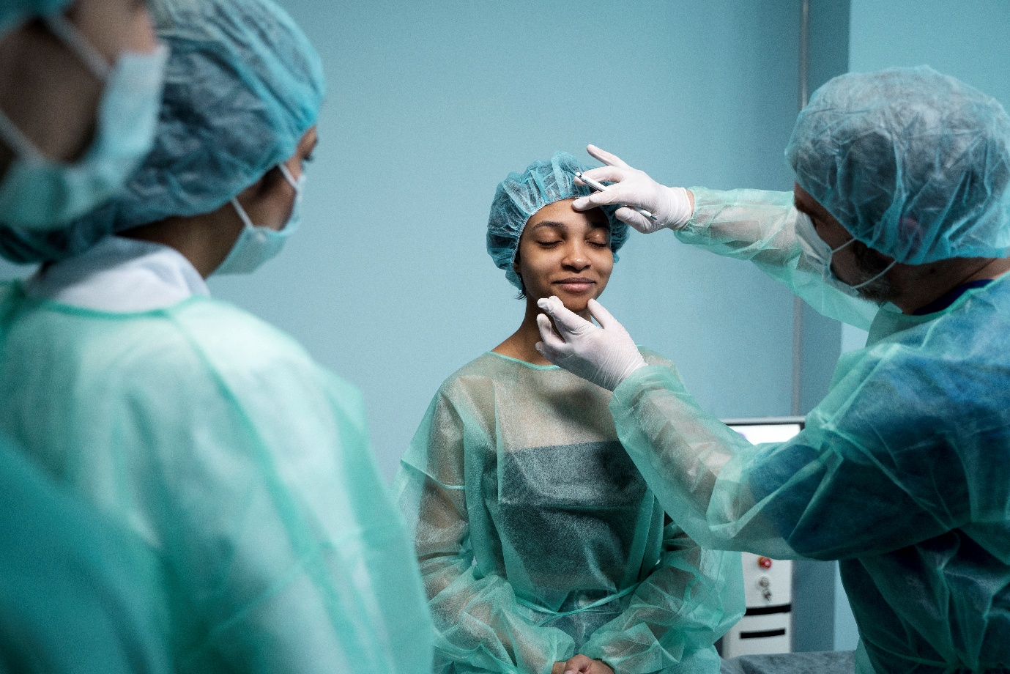

Plastic and reconstructive surgery focuses on repairing and reshaping body parts affected by birth defects, trauma, diseases, or ageing. The word 'reconstructive' means to rebuild something damaged or altered, whether externally visible or internally.

At Aditya Birla Memorial Hospital, we address both functional and aesthetic concerns. Whether repairing a cleft lip, restoring form after cancer surgery, managing burns, or enhancing appearance through cosmetic surgery, our goal is to improve health, restore confidence, and help patients regain their quality of life.

Our team includes highly skilled plastic surgeons in Pimpri Chinchwad who are trained in managing everything from minor cosmetic procedures to complex reconstructive surgeries. We take a personalised approach to every case, ensuring that each treatment plan is tailored to the patient’s unique medical and personal needs.

Why Aditya Birla Memorial Hospital

At Aditya Birla Memorial Hospital, we believe that healing is both functional and emotional. Here’s why we are considered a leading plastic and reconstructive surgery hospital in Pimpri, Pune:

- Multidisciplinary Team Approach: Collaboration between plastic surgeons, dermatologists, oncologists, orthopaedics, and more.
- Modern Operating Suites and Technologies: Equipped with microsurgery setups, laser tools, and infection-free procedure areas.
- Expertise in Diverse Procedures: From burn care and trauma reconstruction to aesthetic enhancements and birth defect corrections.
- Personalised Treatment Plans: Based on patient needs, recovery goals, and lifestyle.
- Accredited Infrastructure: NABH-accredited hospital adhering to the highest safety and quality standards.
- Patient-Centric Care: From consultation to recovery, emotional and psychological support throughout the surgical journey.

Treatment & Procedure

Minimal Invasive and Reconstructive Surgery: Our minimally invasive and reconstructive surgeries use the latest techniques to promote faster healing and less scarring. Whether you have had trauma, burns, or congenital defects, our team is here to help restore your body’s function and appearance.
- Reconstructive surgeries: We provide expert surgical repair for injuries, severe burns, and congenital conditions like cleft lip and palate. These surgeries aim to restore form and essential functions such as movement, speech, or eating.
- Cosmetic and aesthetic procedures: From facial rejuvenation to body contouring, our aesthetic surgeries are tailored to enhance your natural features. We offer rhinoplasty, liposuction, tummy tucks, and facelifts, all performed with an artistic and medical balance.
- Post-cancer reconstruction: If you have undergone cancer treatment, our post-cancer reconstruction services help rebuild affected areas such as the breast, head, or neck, restoring your confidence and appearance.
- Hand and microsurgery: We also specialise in hand and microsurgery, treating injuries and nerve damage to help you regain mobility and sensation.
- Scar revision and skin grafting: We use grafts, tissue flaps, and laser techniques to improve the appearance of scars and damaged skin. The goal is to restore a more natural look while maintaining skin integrity and health.
- Complex wound management and tissue reconstruction: We treat chronic wounds, ulcers, and soft tissue loss using advanced methods like vacuum-assisted closure and flap coverage. These treatments promote healing and prevent complications such as infection or amputation.
- Diabetic foot and pressure sore care: Our experts manage complex wounds, diabetic foot ulcers, and pressure sores with advanced care plans tailored to encourage recovery and prevent further complications.
- Reconstructive support for orthopaedic and oncological cases: We collaborate closely with other specialists in orthopaedics, oncology, and more to offer you comprehensive, multidisciplinary care.

Facilities and Services
• Invasive Liposuction with MicroAire Liposculpt™ System
Experience the latest in power-assisted liposuction, designed to enhance results while significantly reducing complications.
• Non-Invasive Liposuction: Micool Liposculpture™
Achieve visible fat reduction with cryolipolysis technology — clinically proven to eliminate up to 2 inches in just 45 minutes.
• CareLase LSM 40
Improve surgical precision with the world’s most advanced operating microscope, ensuring unmatched accuracy and safety.
• LWR & 3M VAC System
Advanced vacuum-assisted wound therapy to accelerate healing and optimize recovery outcomes.
• DFU & Hair Transplant System
Utilizing one of the most advanced hair restoration systems globally
• Artificial Skin (Dermel Template)
Revolutionary skin substitute used for the treatment of highly complex wounds, offering superior healing and cosmetic results.
• 24/7 Plastic Surgery Services
Our expert plastic surgeons are available around the clock. Outpatient services operate from 9:00 AM to 8:00 PM, with emergency on-call support 24 hours a day. Your surgeon is always just a call away.
• Luxury Patient Experience at Aditya Birla Hospital
Enjoy access to an exclusive lounge and deluxe patient rooms. Whether you're here for a cosmetic procedure or reconstructive surgery, you’ll be treated like royalty throughout your stay.

Frequently Asked Questions (FAQs)

- What is plastic and reconstructive surgery?

Plastic and reconstructive surgery involves techniques for restoring the form and function of the body due to defects from birth, injury, disease, or ageing.
- What is the difference between cosmetic and reconstructive surgery?
Reconstructive surgery focuses on correcting abnormalities to restore function (e.g., repairing a cleft lip or burn injury). Cosmetic surgery, on the other hand, is aimed at enhancing appearance (e.g., rhinoplasty, facelifts). Some procedures may serve both purposes.
- What are the common procedures offered at Aditya Birla Hospital?
At Aditya Birla Memorial Hospital, Pune, we offer:
- Trauma reconstruction
- Burn and wound care
- Cleft lip/palate repair
- Breast reconstruction
- Hand and microvascular surgeries
- Aesthetic procedures like liposuction, eyelid surgery, and facelifts

- Is plastic surgery safe?

Yes, plastic surgery is generally safe when performed by experienced and qualified surgeons under sterile, well-equipped conditions. At Aditya Birla Memorial Hospital, we conduct thorough pre-op evaluations to minimise risks.

- How do I book an appointment?

You can call 9881123006 to book an appointment and schedule a consultation with our team of the best plastic surgeons in the Pimpri-Chinchwad area.

